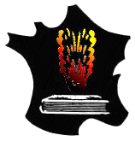
CALL FOR ABSTRACTS
Thematic workshop GFC
COMBUSTION AND MACHINE LEARNING
Wednesday 27th March 2024

IFP Energies Nouvelles, Rueil-Malmaison

Speaker information :

Name : Surname :

Laboratory/ :
Company

Address :

E-mail :

Presentation title, list of authors (Name Surname), affiliation
(laboratory name and city) if different from the speaker

Abstract (5-10 lines)

Please return this form before the 31st of January 2024 to cedric.mehl@ifpen.fr

For any additional information please contact cedric.mehl@ifpen.fr

