The French section of the combustion institute (GFC)
Invites you to a thematic workshop on
COMBUSTION AND MACHINE LEARNING
Wednesday 27th March at IFP Energies Nouvelles, Rueil-Malmaison
and broadcast online
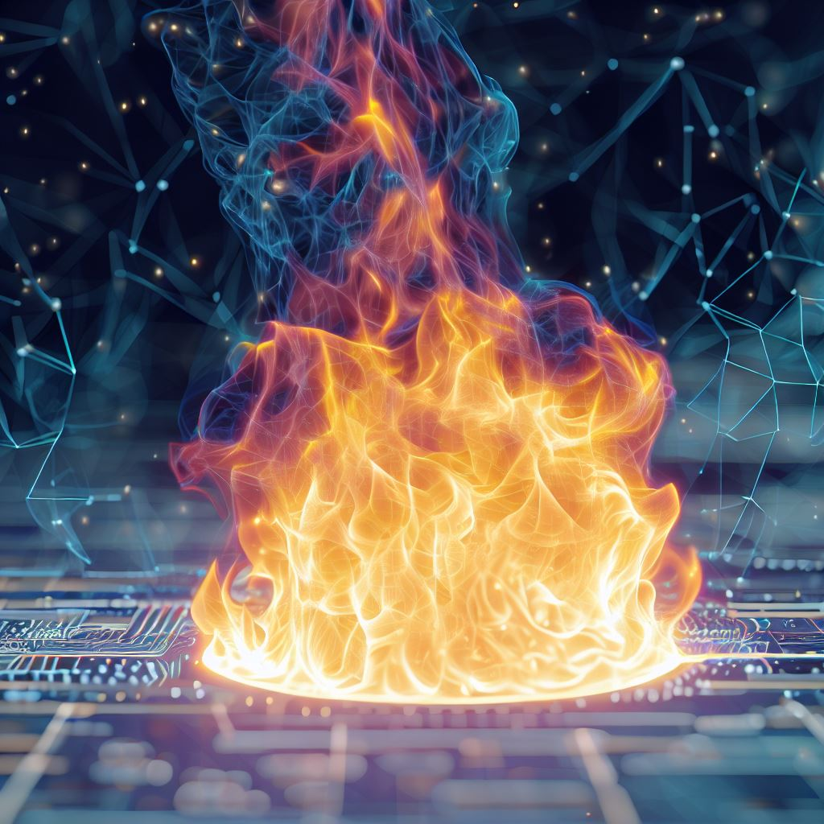
The use of Machine Learning (ML) has infused in a wide range of technology-related domains in the past years. It enables to tackle unsolved problems from a different angle. Combustion makes no exception, and an increasing number of works combining combustion science and ML techniques have been published recently.
A popular use of ML in combustion focuses on the improvement of simulation techniques, from an accuracy or computational efficiency perspective. It can indeed be used to enhance existing subgrid scale models in LES and RANS. ML algorithms, such as neural networks, also offer the possibility to accelerate the computation time of costly operations such as chemistry integration. Moreover, given their ability to tackle large amount of data and elucidate hidden relationships between variables, ML techniques also offer new opportunities in the treatment of experimental data. All sub-fields in combustion science, including experimental techniques, can therefore find benefits in using ML-based methods.
This one-day workshop offers the possibility for participants to present their work combining machine learning and combustion. The program will feature two keynote lectures by respected actors of the field and give an overview of current works on this aspect.

Organizing committee: Cédric MEHL (IFPEN), Roda BOUNACEUR (LRGP) and Corentin LAPEYRE (CERFACS)
Registration: information will be given soon.

